**Memorandum of Understanding**

Status Code 2 Organizing Team

and

Repository

This is to declare the understanding between agreeing parties for the negotiated terms and conditions of association, and it is hereby agreed that **Repository** and **StatusCode 2 Organizing Team** will work together starting from 02/06/2025 to 23/08/2025, on the following terms listed below:

**____________________________________________________________________________**

**Repository** will provide the following:

**____________________________________________________________________________**

1. The **Repository** should generate participant registrations using their unique referral link.

2.The Repository agrees to actively promote StatusCode 2 through its official social media channels and community groups. In addition, the Repository will amplify all promotional posts made by the Organizer by sharing or reposting them through its community platforms.

3. Provide a Point of Contact(PoC) to enable proper communication.

The PoC be preferably handling the social media of Repository and should also facilitate in identifying their community members registering at StatusCode 2

4. Make their presence enough and provide due spread of information to expand our reach.

**____________________________________________________________________________**

**Status Code 2.0** will provide the following: **____________________________________________________________________________**

1. Official announcement and recognition of Repository as a Community Partner on all relevant social media platforms.

2. Acknowledgement during the opening ceremony and closing ceremony.

3. Display of the Community Partner's logo on the official website of StatusCode 2.

4. Applications from Repository for registration will be given Preference.

5. Provide one Swag Kit for 100 Registrations received from the Community’s Devfolio Referral as tracked Event’s Leaderboard. Fake registrations are strictly prohibited and would NOT count.

## **General Understanding:**

This MoU does not constitute any legal or financial obligation for either party and does not guarantee any form of monetary gain. It is purely a good-faith agreement aimed at achieving shared objectives. Both parties acknowledge and accept the terms as final, with no amendments permitted unless agreed to in writing by both parties.

**____________________________________________________________________________**

**Name and Signature of Representatives:**

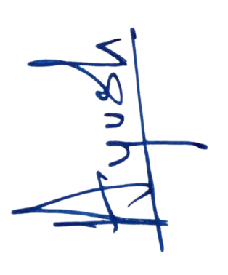

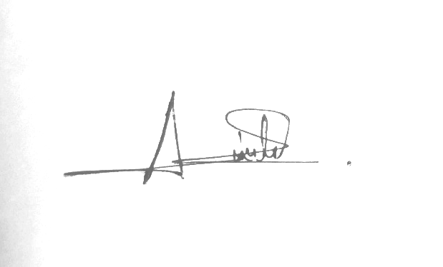

Aniket De Ayush Prasad

Community Lead Secretary

Repository Status Code 2, IIIT Kalyani

Date of Signing : 04/06/2025